**Name: Bhavesh Kewalramani**

**Roll No.: A-25**

**Practical No. 8**

**Theory**

## **Code Optimization-**

|  |
| --- |
| Code Optimization is an approach to enhance the performance of the code. |

The process of code optimization involves-

* Eliminating the unwanted code lines
* Rearranging the statements of the code

## **Advantages-**

The optimized code has the following advantages-

* Optimized code has faster execution speed.
* Optimized code utilizes the memory efficiently.
* Optimized code gives better performance.

## **Code Optimization Techniques-**

Important code optimization techniques are-

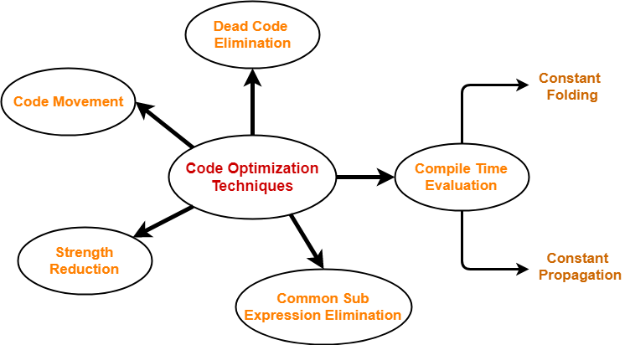

1. Compile Time Evaluation
2. Common sub-expression elimination
3. Dead Code Elimination
4. Code Movement
5. Strength Reduction

## **1. Compile Time Evaluation-**

Two techniques that falls under compile time evaluation are-

### **A) Constant Folding-**

In this technique,

* As the name suggests, it involves folding the constants.
* The expressions that contain the operands having constant values at compile time are evaluated.
* Those expressions are then replaced with their respective results.

### **Example-**

Circumference of Circle = (22/7) x Diameter

Here,

* This technique evaluates the expression 22/7 at compile time.
* The expression is then replaced with its result 3.14.
* This saves the time at run time.

### **B) Constant Propagation-**

In this technique,

* If some variable has been assigned some constant value, then it replaces that variable with its constant value in the further program during compilation.
* The condition is that the value of variable must not get alter in between.

### **Example-**

pi = 3.14

radius = 10

Area of circle = pi x radius x radius

Here,

* This technique substitutes the value of variables ‘pi’ and ‘radius’ at compile time.
* It then evaluates the expression 3.14 x 10 x 10.
* The expression is then replaced with its result 314.
* This saves the time at run time.

## **2. Common Sub-Expression Elimination-**

|  |
| --- |
| The expression that has been already computed before and appears again in the code for computation  is called as **Common Sub-Expression**. |

In this technique,

* As the name suggests, it involves eliminating the common sub expressions.
* The redundant expressions are eliminated to avoid their re-computation.
* The already computed result is used in the further program when required.

### **Example-**

|  |  |
| --- | --- |
| **Code Before Optimization** | **Code After Optimization** |
| S1 = 4 x i  S2 = a[S1]  S3 = 4 x j  S4 = 4 x i **// Redundant Expression**  S5 = n  S6 = b[S4] + S5 | S1 = 4 x I  S2 = a[S1]  S3 = 4 x j  S5 = n  S6 = b[S1] + S5 |

## **3. Code Movement-**

In this technique,

* As the name suggests, it involves movement of the code.
* The code present inside the loop is moved out if it does not matter whether it is present inside or outside.
* Such a code unnecessarily gets execute again and again with each iteration of the loop.
* This leads to the wastage of time at run time.

### **Example-**

|  |  |
| --- | --- |
| **Code Before Optimization** | **Code After Optimization** |
| for ( int j = 0 ; j < n ; j ++)  {  x = y + z ;  a[j] = 6 x j;  } | x = y + z ;  for ( int j = 0 ; j < n ; j ++)  {  a[j] = 6 x j;  } |

## **4. Dead Code Elimination-**

In this technique,

* As the name suggests, it involves eliminating the dead code.
* The statements of the code which either never executes or are unreachable or their output is never used are eliminated.

### **Example-**

|  |  |
| --- | --- |
| **Code Before Optimization** | **Code After Optimization** |
| i = 0 ;  if (i == 1)  {  a = x + 5 ;  } | i = 0 ; |

## **5. Strength Reduction-**

In this technique,

* As the name suggests, it involves reducing the strength of expressions.
* This technique replaces the expensive and costly operators with the simple and cheaper ones.

### **Example-**

|  |  |
| --- | --- |
| **Code Before Optimization** | **Code After Optimization** |
| B = A x 2 | B = A + A |

Here,

* The expression “A x 2” is replaced with the expression “A + A”.
* This is because the cost of multiplication operator is higher than that of addition operator.

**Practicals**

**Aim:**

Write a code to implement Local optimization techniques until no further optimization is

possible for the given three address code.

**Program:**

l=["a=2","b=x^2","c=x","d=a+5","e=b+c","f=c*c","g=d+e","h=e*f"]

lhs=[]

rhs=[]

for i in l:

i,j=i.split("=")

lhs.append(i)

rhs.append(list(j))

index=[]

ind=[]

def Elimination(lhs,rhs):

for i in range(len(lhs)):

if len(rhs[i])==1:

for j in range(i+1,len(rhs)):

for k in range(len(rhs[j])):

if rhs[j][k]==lhs[i]:

rhs[j][k]=rhs[i][0]

nums=[]

count=0

for k in range(len(rhs[j])):

if rhs[j][k].isdigit():

count+=1

if count==2:

nums.append(j)

for x in nums:

if '+' in rhs[x]:

rhs[x]=[str(int(rhs[x][0])+int(rhs[x][2]))]

elif '*' in rhs[x]:

rhs[x]=[str(int(rhs[x][0])*int(rhs[x][2]))]

elif '-' in rhs[x]:

rhs[x]=[str(int(rhs[x][0])-int(rhs[x][2]))]

elif '/' in rhs[x]:

rhs[x]=[str(int(rhs[x][0])/int(rhs[x][2]))]

elif '^' in rhs[nums[x]]:

rhs[x]=[str(int(rhs[x][0])*int(rhs[x][0]))]

if len(rhs[j])==3:

if '^' in rhs[j]:

rhs[j][-2]='*'

rhs[j][-1]=rhs[j][0]

index.append(i)

return lhs,rhs,index

lhs,rhs,index = Elimination(lhs,rhs)

for j in range(len(rhs)):

for k in range(j+1,len(rhs)):

if rhs[j] == rhs[k]:

rhs[k] = [lhs[j]]

lhs,rhs,index = Elimination(lhs,rhs)

t1=lhs.copy()

t2=rhs.copy()

for i in range(len(t2)):

if len(t2[i])==1:

if t2[i] in rhs and t1[i] :

lhs.remove(t1[i])

rhs.remove(t2[i])

for i in range(len(lhs)):

print(lhs[i]," = ",end=" ")

for j in range(len(rhs[i])):

print(rhs[i][j],end=" ")

print()

**Output:**

